McKean County Housing Authority
2023 Calendar

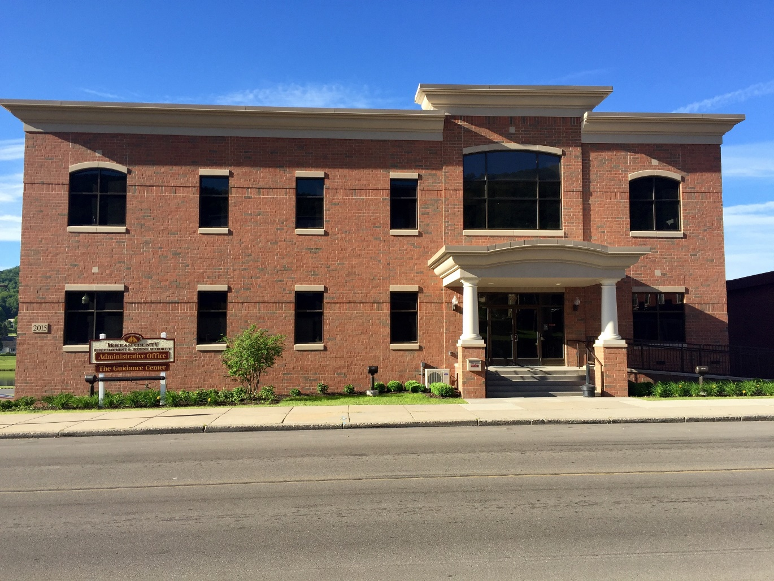

Tenant

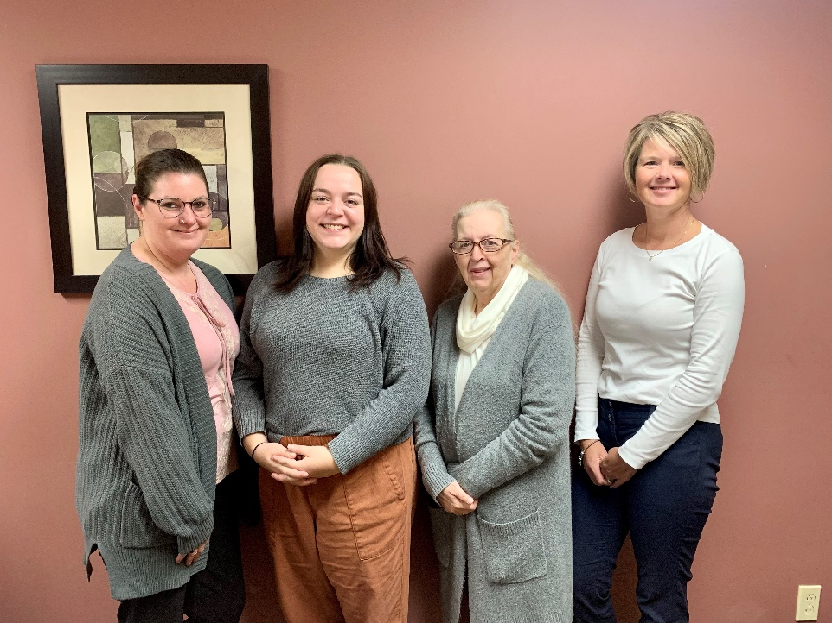

Housing and Homeless Services Department
Amber, Abby, Kathy and Michelle
Bradford Office

January 2023
Sunday | Monday | Tuesday | Wednesday | Thursday | Friday | Saturday
LEGEND
Maintenance
Public Housing
Central Towers
S8
Redevelopment
Administration
Accounting
HHS
HVAC

1  RENT DUE  New Contracts go into effect for FV tenants  New Year’s Day | 2  OFFICE CLOSED | 3  Evictions Delivered  ANNUAL RECERT packets sent to Bradford High-Rise tenants | 4  HOUSEKEEPING INSPECTIONS Central Towers Floors 1,2,3 | 5  ACH Withdrawal (5th) | 6 | 7  Emergency Calls  Residents of Port, Eldred, Smethport, Foster Township, Lewis Run  558-8824
8  HOUSEKEEPING INSPECTIONS  Conducted this week: Allegany Apts, Cris Dr, Mill St, Brooklynside, Fosterview, Brookline Ct.,  South Center | 9 | 10 | 11  ANNUAL CONTRACTS due back from Allegany Apts, Center Hall, Helmer Hall, Vanderhule, Phillips Street | 12 | 13 | 14  Emergency Calls  Residents of City of Bradford  598-3184
15  HOUSEKEEPING INSPECTIONS  Conducted this week: Dickinson, Medberry, Page Place | 16  Late Charges Added  OFFICE CLOSED  Martin Luther King, Jr. Day | 17  Late Notices Mailed | 18  ACH Withdrawal (3rd Wednesday) | 19 | 20 | 21  Emergency Calls  Residents of Kane & Mt. Jewett  598-0405
22 | 23 | 24 | 25 | 26 | 27 | 28
29 | 30  PA-1000 Rent Certificate Forms mailed to residents | 31  ANNUAL CONTRACTS start going in the mail for Dickinson Manor, Medberry Manor, Page Place, Jenny L Manor, Riley Road, The Abbie tenants

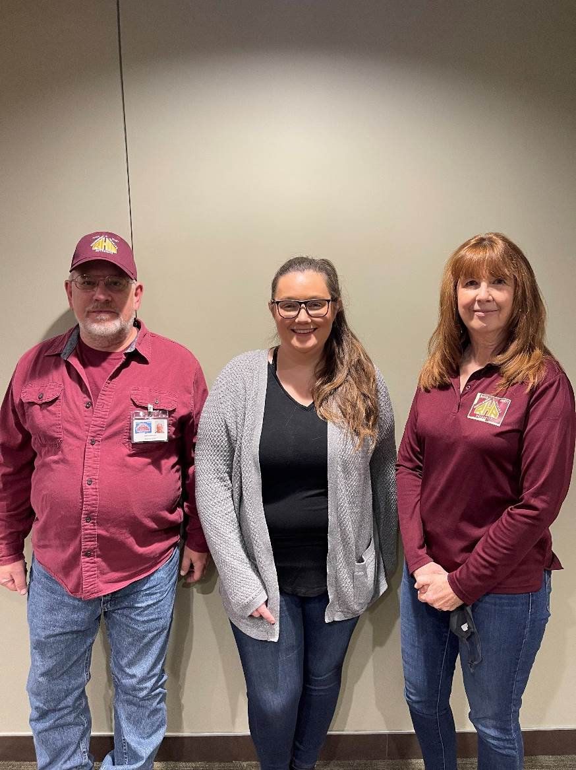

Section 8
Steve, Casey, Anne
February 2023
Sunday | Monday | Tuesday | Wednesday | Thursday | Friday | Saturday
LEGEND  Maintenance  Public Housing  Central Towers  S8  Redevelopment  Administration  Accounting  HHS  HVAC |  |  | 1  HOUSEKEEPING INSPECTIONS Central Towers Floors 4,5,6  RENT DUE  Evictions Delivered  New Contracts go into effect for Allegany Apts, Center Hall, Helmer Hall, Vanderhule, Phillips Street tenants  ANNUAL RECERT  packets sent to  Cris Drive, Mill Street, Brooklynside | 2  Groundhog Day | 3 | 4  Emergency Calls  Residents of Port, Eldred, Smethport, Foster Township, Lewis Run  558-8824
5 | 6  ACH Withdrawal (5th) | 7 | 8 | 9  ANNUAL CONTRACTS due back from Dickinson Manor, Medberry Manor, Page Place, Jenny L Manor, Riley Road, The Abbie tenants | 10 | 11  Emergency Calls  Residents of City of Bradford  598-3184
12  HOUSEKEEPING INSPECTIONS  Conducted this week: Vanderhule, Helmer Hall, Welsh St, Phillips St, Center Hall, Bradford High-Rise | 13 | 14  Valentine’s Day | 15  ACH Withdrawal (3rd Wednesday) | 16  Late Charges Added  Late Notices Mailed | 17 | 18  Emergency Calls  Residents of Kane & Mt. Jewett  598-0405
19  HOUSEKEEPING INSPECTIONS  Conducted this week: Jenny L, Riley Road, Lewis Run | 20  OFFICE CLOSED  President’s Day | 21 | 22 | 23 | 24 | 25
26 | 27 | 28

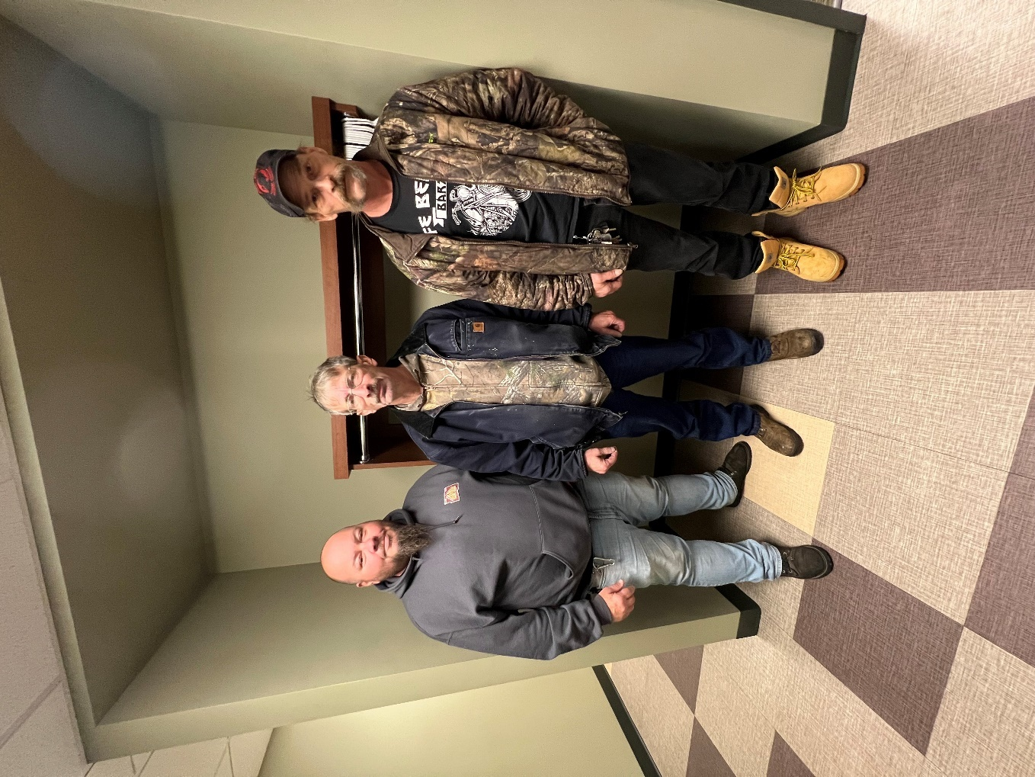

Bradford Maintenance
Mike, Carl, Brian

March 2023
Sunday | Monday | Tuesday | Wednesday | Thursday | Friday | Saturday
LEGEND  Maintenance  Public Housing  Central Towers  S8  Redevelopment  Administration  Accounting  HHS  HVAC |  |  | 1  HOUSEKEEPING INSPECTIONS Central Towers Floors 1,2,3  RENT DUE  Evictions Delivered  New Contracts go into effect for Dickinson Manor, Medberry Manor, Page Place, Jenny L Manor, Riley Road, & The Abbie tenants | 2 | 3 | 4
5 | 6  ACH Withdrawal | 7 | 8  SYSTEM INSPECTIONS  South Center (if necessary) | 9 | 10 | 11
12  Daylight Savings Begins | 13  *Maintenance winter hours end 8am-4pm | 14 | 15  ACH Withdrawal (3rd Wednesday)  SYSTEM INSPECTIONS  Allegany Apts.  Cris Drive  Mill Street  Vanderhule  South Center  Central Towers | 16  Late Charges Added  Late Notices Mailed | 17  St. Patrick’s Day | 18  Emergency Calls  Residents of Port, Eldred, Smethport, Foster Township, Lewis Run  558-8824
19 | 20  Spring Begins | 21  OFFICE CLOSED ALL DAY STAFF TRAINING | 22  SYSTEM INSPECTIONS  Lewis Run, Fosterview,  Riley Rd,  Phillips Street, Eastview,  Brookline Court | 23  SYSTEM INSPECTIONS  Medberry Manor, Page Place, Helmer Hall, Brooklynside, Bradford High-Rise | 24  SYSTEM INSPECTIONS  Bradford High-Rise (if necessary) | 25  Emergency Calls  Residents of City of Bradford  598-3184
26 | 27 | 28 | 29  SYSTEM INSPECTIONS  Dickinson Manor, Center Hall, Smethport Commons, Boylston,  Jenny L Manor,  Welsh Street | 30  ANNUAL CONTRACTS start going in mail for  High Rise tenants |  | Emergency Calls  Residents of Kane & Mt. Jewett  598-0405

Smethport
Housing Staff
Amber and Damian

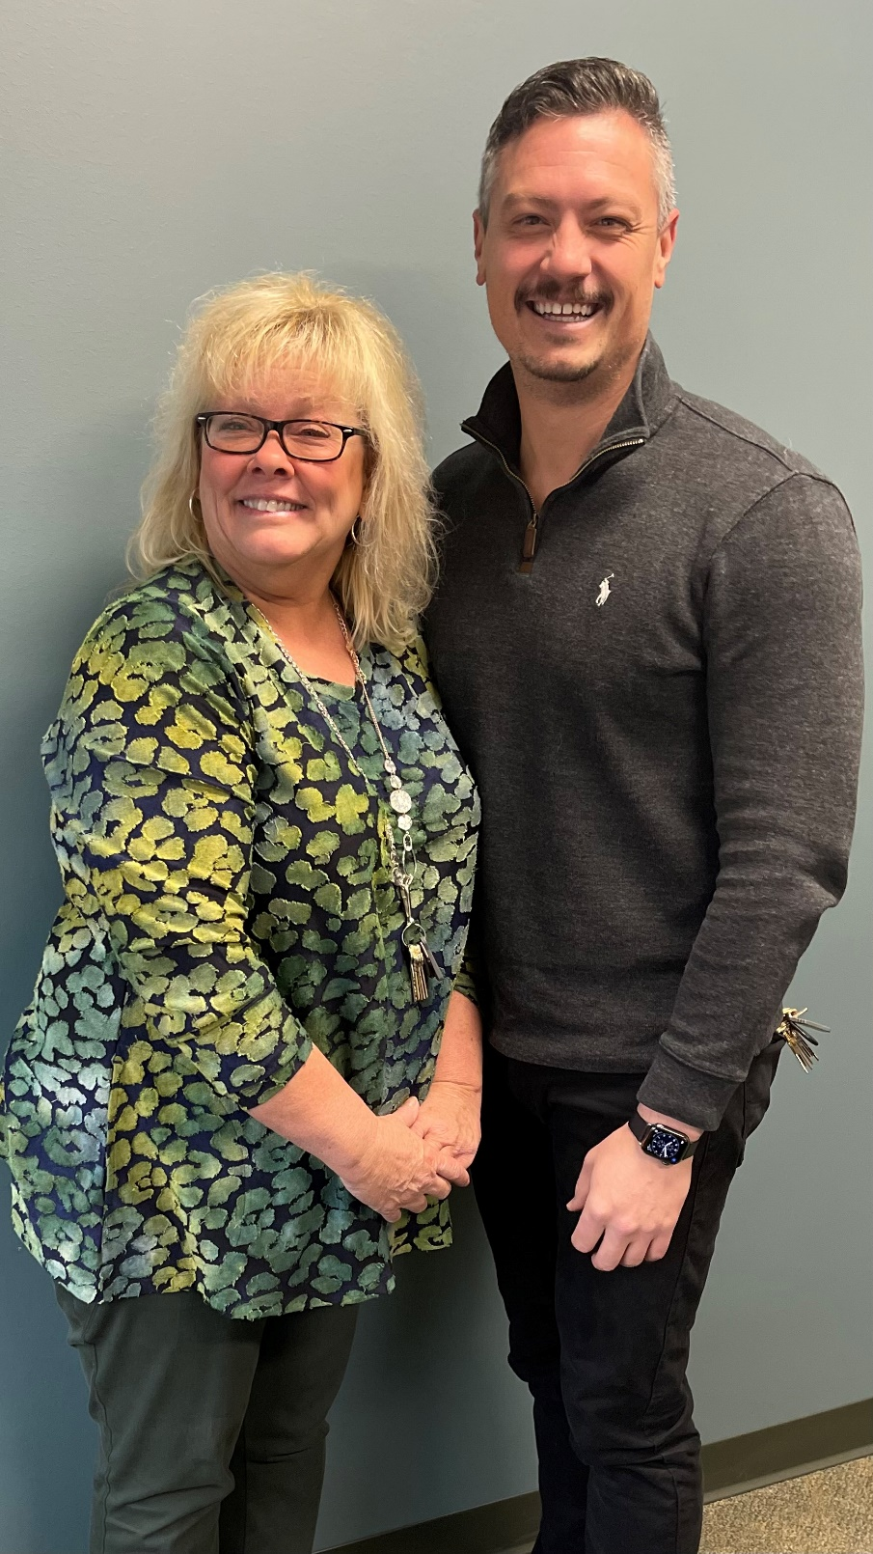

April 2023
Sunday | Monday | Tuesday | Wednesday | Thursday | Friday | Saturday
LEGEND  Maintenance  Public Housing  Central Towers  S8  Redevelopment  Administration  Accounting  HHS  HVAC |  |  |  |  |  | RENT DUE  Evictions Delivered  ANNUAL RECERT packets sent to Brookline Court & South Center tenants  April Fool’s Day
2 | 3  Emergency Calls  Residents of Port, Eldred, Smethport, Foster Township, Lewis Run  558-8824 | 4 | 5  HOUSEKEEPING INSPECTIONS Central Towers Floors 4,5,6  ACH Withdrawal (5th) | 6 | 7  OFFICE CLOSED  Good Friday | 8  Emergency Calls  Residents of City of Bradford  598-3184
9  HOUSEKEEPING INSPECTIONS  Conducted this week: Vanderhule, Helmer Hall, Welsh St, Phillips St, Center Hall, Bradford High-Rise  Easter Sunday | 10 | 11  ANNUAL CONTRACTS due back from High Rise tenants | 12 | 13 | 14 | 15  Emergency Calls  Residents of Kane & Mt. Jewett  598-0405
16  Late Charges Added  HOUSEKEEPING INSPECTIONS  Conducted this week: Dickinson, Medberry, Page Place | 17  Late Notices Mailed | 18 | 19 | 20 | 21 | 22  Earth Day
23 | 24 | 25 | 26  ACH Withdrawal (3rd Wednesday) | 27 | 28  ANNUAL CONTRACTS start going in mail for  Mill Street, Cris Dr, Brooklynside tenants | 29
30

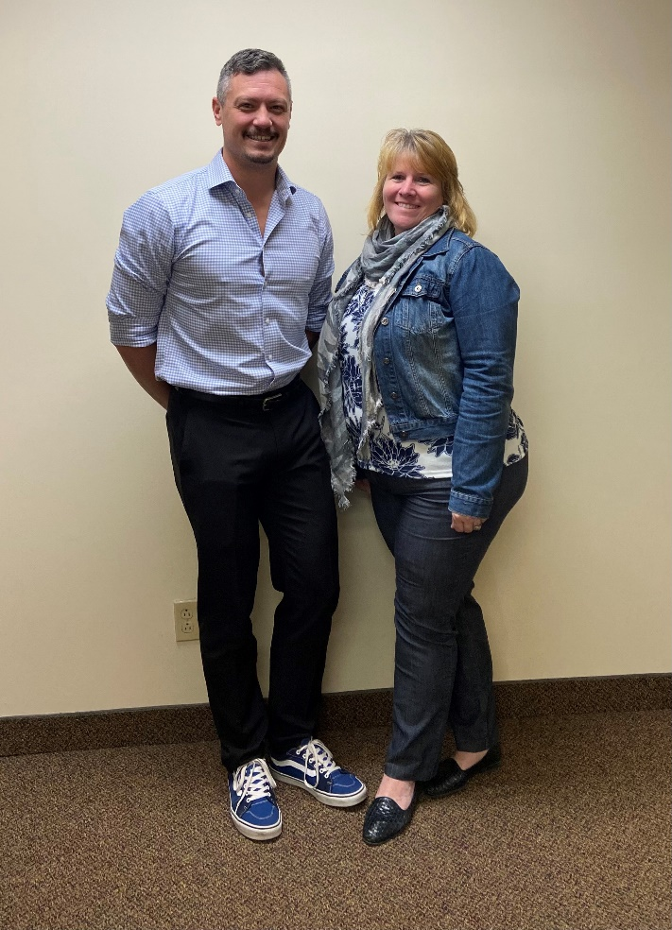
Bradford Housing Staff
Jessica Burkett
Director of Housing

and
Director of Facilities &Community Development
Damian and Lori

May 2023
Sunday | Monday | Tuesday | Wednesday | Thursday | Friday | Saturday
LEGEND  Maintenance  Public Housing  Central Towers  S8  Redevelopment  Administration  Accounting  HHS  HVAC | 1  RENT DUE  New Contracts go into effect for Bradford High-Rise tenants  Evictions Delivered | 2 | 3 | 4 | 5  ACH Withdrawal (5th) | 6
7  May Day | 8 | 9 | 10  HOUSEKEEPING INSPECTIONS Central Towers Floors 1,2,3 | 11 | 12 | 13  Emergency Calls  Residents of Port, Eldred, Smethport, Foster Township, Lewis Run  558-8824
14  HOUSEKEEPING INSPECTIONS  Conducted this week: Allegany Apts, Cris Dr, Mill St, Brooklynside, Fosterview, Brookline Ct., South Center  Mother’s Day | 15 | 16  Late Charges Added  Late Notices Mailed | 17  ACH Withdrawal (3rd Wednesday) | 18  ANNUAL CONTRACTS due back from  Mill Street, Cris Dr, Brooklynside tenants | 19 | 20  Emergency Calls  Residents of City of Bradford  598-3184  Armed Forces Day
21  HOUSEKEEPING INSPECTIONS  Conducted this week: Jenny L, Riley Road, Lewis Run | 22 | 23 | 24 | 25 | 26 | 27  Emergency Calls  Residents of Kane & Mt. Jewett  598-0405
28 | 29  OFFICE CLOSED  Memorial Day | 30 | 31

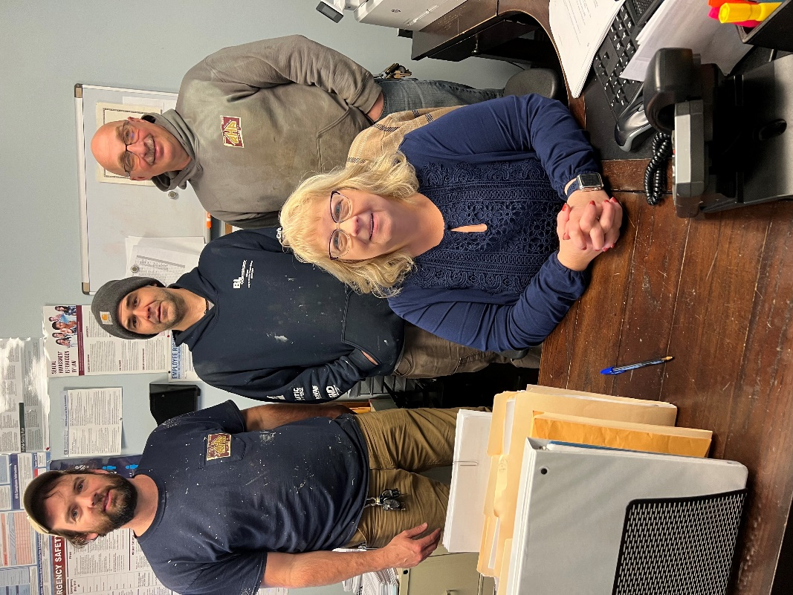

Kane Staff
Dustin, Erik, Pat, Brenda

June 2023
Sunday | Monday | Tuesday | Wednesday | Thursday | Friday | Saturday
LEGEND  Maintenance  Public Housing  Central Towers  S8  Redevelopment  Administration  Accounting  HHS  HVAC |  |  |  | 1  RENT DUE  Evictions Delivered  New Contracts go into effect for Cris Drive, Mill St., & Brooklynside tenants  ANNUAL RECERT  packets start being sent for Central Towers | 2 | 3  Emergency Calls  Residents of Port, Eldred, Smethport, Foster Township, Lewis Run  558-8824
4 | 5  ACH Withdrawal (5th)  SPRING CLEAN UP | 6 | 7 | 8  ANNUAL INSPECTIONS  Bradford High-Rise | 9  ANNUAL INSPECTIONS  Bradford High-Rise | 10  Emergency Calls  Residents of City of Bradford  598-3184
11 | 12 | 13 | 14  Flag Day | 15 | 16  ANNUAL INSPECTIONS  Port Allegany  ANNUAL INSPECTIONS  Port Allegany  Late Charges Added  Late Notices Mailed | 17  Emergency Calls  Residents of Kane & Mt. Jewett  598-0405
18  Father’s Day  Juneteenth | 19  OFFICE CLOSED  Juneteenth | 20 | 21  ANNUAL INSPECTIONS  Brookline Court  ACH Withdrawal (3rd Wednesday)  Summer Begins | 22 | 23 | 24
25 | 26 | 27  ANNUAL INSPECTIONS  Smethport & Commons | 28  ANNUAL INSPECTIONS  Central Towers | 29 | 30  ANNUAL CONTRACTS start going in mail for South Center & Brookline Court tenants

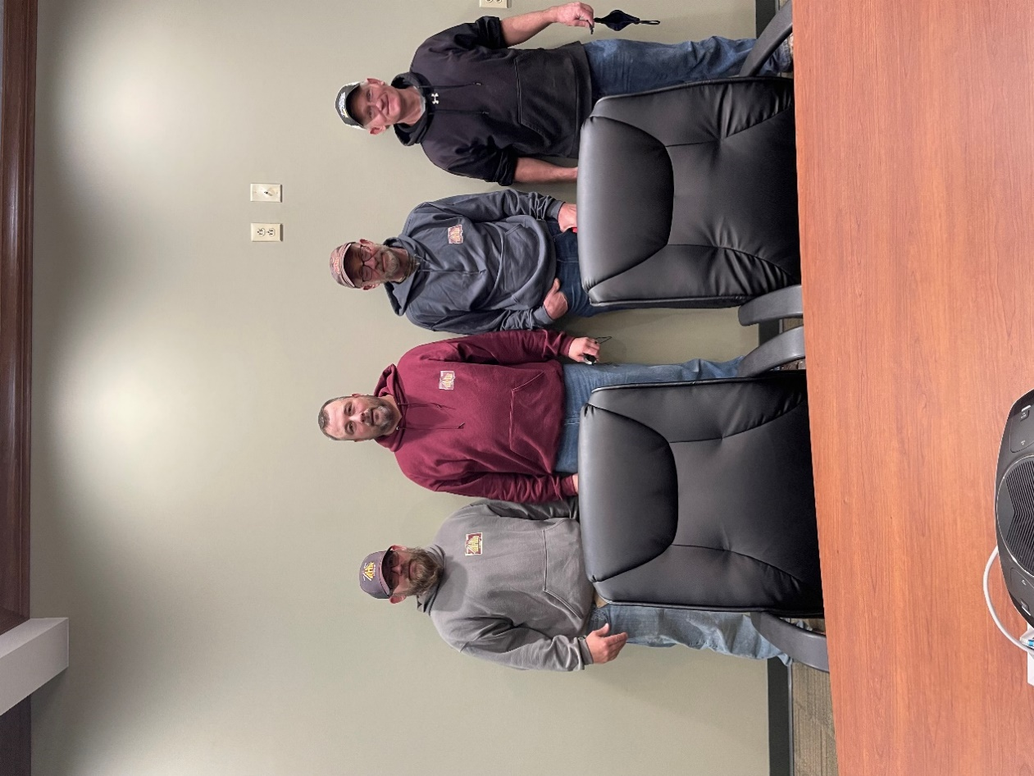
Smethport Maintenance Staff
Chad, Steve, Walt, Chris
July 2023
Sunday | Monday | Tuesday | Wednesday | Thursday | Friday | Saturday
LEGEND  Maintenance  Public Housing  Central Towers  S8  Redevelopment  Administration  Accounting  HHS  HVAC |  |  |  |  |  | 1  RENT DUE
2 | 3  Evictions Delivered | 4  OFFICE CLOSED  Independence Day | 5  ANNUAL INSPECTIONS  Mt. Jewett/Eastview  ACH Withdrawal (5th) | 6  ANNUAL INSPECTIONS  South Center  (even numbers)  91 Boylston Street | 7 | 8  Emergency Calls  Residents of Port, Eldred, Smethport, Foster Township, Lewis Run  558-8824
9 | 10 | 11 | 12 | 13  ANNUAL INSPECTIONS  Riley Rd/ Fosterview  Lewis Run | 14 | 15  Emergency Calls  Residents of City of Bradford  598-3184
16  Late Charges Added | 17  Late Notices Mailed | 18 | 19  ANNUAL INSPECTIONS  Welsh Street  ACH Withdrawal (3rd Wednesday) | 20  ANNUAL INSPECTIONS  Eldred | 21  OFFICE CLOSED ALL DAY STAFF TRAINING | 22  Emergency Calls  Residents of Kane & Mt. Jewett  598-0405
23 | 24 | 25 | 26  ANNUAL INSPECTIONS  South Center  (odd numbers) | 27 | 28 | 29
30 | 31

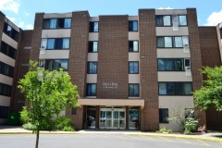
City of Bradford Properties
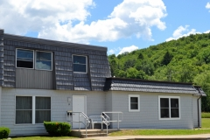

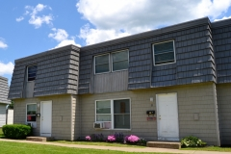
Bradford High-Rise Brookline Court

South Center

August 2023
Sunday | Monday | Tuesday | Wednesday | Thursday | Friday | Saturday
LEGEND  Maintenance  Public Housing  Central Towers  S8  Redevelopment  Administration  Accounting  HHS  HVAC | Emergency Calls  Residents of Port, Eldred, Smethport, Foster Township, Lewis Run  558-8824 | Emergency Calls  Residents of City of Bradford  598-3184 | Emergency Calls  Residents of Kane & Mt. Jewett  598-0405
 |  | 1  RENT DUE  Evictions Delivered  New Contracts go into effect for Brookline Court & South Center tenants  ANNUAL RECERT  Packets sent to Welsh Street | 2  HOUSEKEEPING INSPECTIONS Central Towers Floors 4,5,6 | 3 | 4 | 5  ACH Withdrawal (5th)
6 | 7 | 8 | 9  Annual Packets Due Back from Welsh Street | 10 | 11 | 12
13  HOUSEKEEPING INSPECTIONS  Conducted this week: Vanderhule, Helmer Hall, Welsh St, Phillips St, Center Hall, Bradford High-Rise | 14 | 15 | 16  ACH Withdrawal (3rd Wednesday)  Late Charges Added  Late Notices Mailed | 17 | 18 | 19
20  HOUSEKEEPING INSPECTIONS  Conducted this week: Jenny L, Riley Road, Lewis Run | 21 | 22 | 23 | 24 | 25 | 26
27 | 28 | 29 | 30 | 31  ANNUAL CONTRACTS  Central Towers Distributed

Eldred Properties

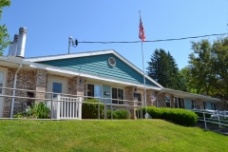
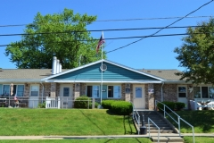

Jenny L Manor
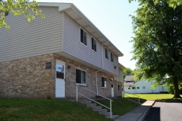

Allegany Apartments

September 2023
Sunday | Monday | Tuesday | Wednesday | Thursday | Friday | Saturday
LEGEND  Maintenance  Public Housing  Central Towers  S8  Redevelopment  Administration  Accounting  HHS  HVAC |  |  |  |  | 1  RENT DUE  Evictions Delivered  ANNUAL RECERT  Packets sent to Fosterview | 2
3 | 4 | 5  OFFICE CLOSED  Labor Day  ACH Withdrawal (5th) | 6  HOUSEKEEPING INSPECTIONS Central Towers Floors 1,2,3 | 7 | 8 | 9
10  HOUSEKEEPING INSPECTIONS  Conducted this week: Allegany Apts, Cris Dr, Mill St, Brooklynside, Fosterview, Brookline Ct., South Center | 11  Annual Packets Due Back from Fosterview  Grandparent’s Day | 12 | 13 | 14 | 15  ALL BALANCES MUST BE @ $0  Evictions Delivered | 16  Late Charges Added
17 | 18  Late Notices Delivered | 19 | 20  ACH Withdrawal (3rd Wednesday)  Autumn Begins | 21 | 22 | 23  Autumn Begins
24 | 25 | 26 | 27 | 28 | 29  ALL BALANCES MUST BE @ $0 OR UNITS VACATED | 30
Emergency Calls  Residents of Port, Eldred, Smethport, Foster Township, Lewis Run  558-8824 | Emergency Calls  Residents of City of Bradford  598-3184 | Emergency Calls  Residents of Kane & Mt. Jewett  598-0405

Port Allegany Properties
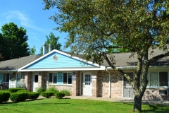
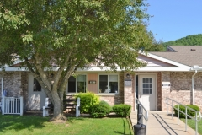

Page Place Medberry Manor

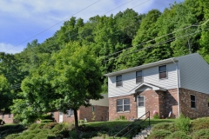
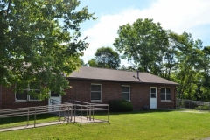

Brooklynside

October 2023
Sunday | Monday | Tuesday | Wednesday | Thursday | Friday | Saturday
LEGEND
Maintenance
Public Housing
Central Towers
S8
Redevelopment
Administration
Accounting
HHS
HVAC

1  RENT DUE  CENTRAL TOWERS CONTRACTS go into effect | 2  Evictions Delivered  ANNUAL RECERT  Packets sent to Allegany Apts, Center Hall, Helmer Hall, Vanderhule & Phillips St | 3 | 4  SYSTEM INSPECTIONS  Mill Street, Cris Drive  Vanderhule, South Center, Allegany Apts, Central Towers  HOUSEKEEPING INSPECTIONS Central Towers Floors 4,5,6 | 5  SYSTEM INSPECTIONS  South Center (if necessary)  ACH Withdrawal (5th) | 6 | 7  Emergency Calls  Residents of Port, Eldred, Smethport, Foster Township, Lewis Run  558-8824
8 | 9  Columbus Day | 10  Annual Packets Due Back from Allegany Apartments, Cris Drive, Helmer Hall, Vanderhule& Phillips Street | 11  SYSTEM INSPECTIONS  Lewis Run,  Riley Road, Fosterview,  Brookline Court.  Phillips Street, Eastview | 12 | 13 | 14  Emergency Calls  Residents of City of Bradford  598-3184
15  Late Charges Added | 16  Late Notices Mailed | 17  OFFICE CLOSED ALL DAY STAFF TRAINING | 18  ACH Withdrawal (3rd Wednesday)  SYSTEM INSPECTIONS  Medberry Manor, Page Place, Helmer Hall, Brooklynside, Bradford High-Rise | 19  SYSTEM INSPECTIONS  Bradford High-Rise (if necessary) | 20 | 21  Emergency Calls  Residents of Kane & Mt. Jewett  598-0405
22 | 23 | 24 | 25  SYSTEM INSPECTIONS  Dickinson Manor, Center Hall, Smethport Commons, Boylston,  Jenny L Manor,  Welsh Street | 26 | 27 | 28
29 | 30 | 31  ANNUAL CONTRACTS start going in mail for Welsh Street tenants  Halloween

Foster Township / Lewis Run Properties
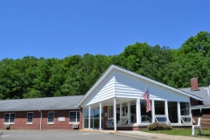

Riley Road

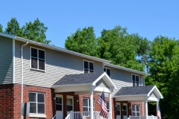
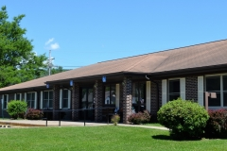

Fosterview The Abbie

November 2023

Sunday | Monday | Tuesday | Wednesday | Thursday | Friday | Saturday
LEGEND  Maintenance  Public Housing  Central Towers  S8  Redevelopment  Administration  Accounting  HHS  HVAC |  |  | 1  HOUSEKEEPING INSPECTIONS Central Towers Floors 1,2,3  RENT DUE  Evictions Delivered  ANNUAL RECERT packets sent to Dickinson, Jenny L, Medberry, Page Pl., Lewis Run, & Riley Road tenants | 2 | 3 | 4
5  Daylight Savings Ends | 6  *Maintenance winter hours begin 7am-3pm  ACH Withdrawal (5th) | 7 | 8 | 9  ANNUAL CONTRACTS due back from Welsh Street tenants | 10  OFFICE CLOSED | 11  Veterans Day
12  HOUSEKEEPING INSPECTIONS  Conducted this week: Allegany Apts, Cris Dr, Mill St, Brooklynside, Fosterview, Brookline Ct., South Center | 13 | 14 | 15  Late Charges Added  Late Notices Mailed  ACH Withdrawal (3rd Wednesday) | 16 | 17 | 18
19  HOUSEKEEPING INSPECTIONS  Conducted this week: Jenny L, Riley Road, Lewis Run | 20 | 21 | 22 | 23  OFFICE CLOSED  Thanksgiving  Thanksgiving | 24  OFFICE CLOSED | 25
26 | 27 | 28 | 29  ANNUAL CONTRACT start going in mail for Fosterview tenants | 30  Emergency Calls  Residents of City of Bradford  598-3184 | Emergency Calls  Residents of Kane & Mt. Jewett  598-0405 | Emergency Calls  Residents of Port, Eldred, Smethport, Foster Township, Lewis Run  558-8824

Kane / Mt. Jewett Properties
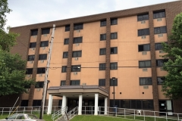

Central Towers

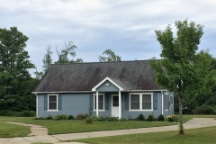
Phillips Street

December 2023
Sunday | Monday | Tuesday | Wednesday | Thursday | Friday | Saturday
LEGEND  Maintenance  Public Housing  Central Towers  S8  Redevelopment  Administration  Accounting  HHS  HVAC |  |  |  |  | 1  RENT DUE  Evictions Delivered  New Contracts go into effect for Welsh Street tenants | 2
3 | 4 | 5  ACH Withdrawal (5th) | 6  HOUSEKEEPING INSPECTIONS Central Towers Floors 4,5,6 | 7 | 8 | 9  Emergency Calls  Residents of Port, Eldred, Smethport, Foster Township, Lewis Run  558-8824
10  HOUSEKEEPING INSPECTIONS  Conducted this week: Vanderhule, Helmer Hall, Welsh St, Phillips St, Center Hall, Bradford High-Rise | 11  ANNUAL CONTRACTS due back from Fosterview tenants | 1 | 13 | 14 | 15 | 16  Emergency Calls  Residents of City of Bradford  598-3184
17  Hanukkah Begins | 18  Late Charges Added  Late Notices Mailed | 19 | 20  ACH Withdrawal (3rd Wednesday)  Winter Starts | 21 | 22  OFFICE CLOSED | 23  Emergency Calls  Residents of Kane & Mt. Jewett  598-0405
24  Christmas Eve | 25  OFFICE CLOSED  Christmas Day | 26 | 27 | 28 | 29  ANNUAL CONTRACTS start going in mail for Allegany Apts, Center Hall, Helmer Hall, Vanderhule, Phillips Street | 30
31

New Year’s Eve

